**Drysdale, Russell (1912–1981)**

Russell Drysdale created an original vision of the Australian landscape from the 1940s to the 1960s, portraying the emptiness and loneliness of the Australian outback and country townships in his paintings, drawings and photographs. During the Second World War he depicted everyday subjects including groups of servicemen waiting at railway stations. He travelled numerous times to the interior of Australia, including a trip to record the drought devastation in South Western New South Wales in 1944, where he created images that convey the environmental degradation of the landscape. In 1947 he explored the Bathurst region with Donald Friend where he discovered Sofala and Hill End, an area that became his subject matter for a number of years. Drysdale painted many images of deserted country towns as well as brooding landscapes peopled with stockmen and station hands. In his paintings of Aborigines Drysdale expressed a deep concern for the Indigenous people, often placing them within his paintings in a manner that conveys a sense of dispossession. His work was singled out by Kenneth Clark in 1949 as being among the most original in Australian art, and his exhibition at the Leicester Galleries, London, in 1950 convinced British critics that Australian artists had an original vision.

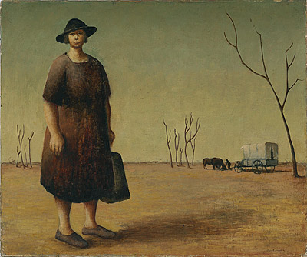

Russell Drysdale, *The Drover’s Wife*, 1945, oil on canvas, 51.5x61.5 cm, National Gallery Australia, Accession No: NGA 87.1612.

The son of an Anglo-Australian pastoralist, he was born in Bognor Regis, Sussex, on 7 February 1912. He travelled to Australia with his family twice as a child, including a two-year stay in North Queensland in 1919–21 before he settling permanently in Melbourne with his family in 1923, aged eleven. He attended Geelong Grammar School as a boarder, where many of his fellow students came from the country and shared a common interest in life on the land. In 1929 Drysdale developed a detached retina in his left eye, a condition which haunted him for the rest of his life. While in hospital recovering from eye treatment, he was encouraged to take up art. He visited Europe, 1932–34 and returned to Melbourne in 1935. From 1935 to 1938 he studied art in Melbourne with George Bell. Between 1938 and 1939 Drysdale travelled to London, where he attended Iain Macnab’s Grosvenor School of Modern Art, and to Paris. He moved to Sydney in 1940.

In 1954 Drysdale represented Australia at the Venice Biennale. He moved to Hardy’s Bay, New South Wales in 1966 and died in Sydney on 29 June 1981. His work is held by all major Australian galleries, the Tate in London, and the Metropolitan Museum of Art, New York. He has been the subject of several surveys and a touring retrospective was organised by the National Gallery of Victoria, Melbourne, in 1997.

**References and further reading**:

Burke, Joseph. (1951) The Paintings of Russell Drysdale, Sydney: Ure Smith.

Dutton, Geoffrey. (1964) *Russell Drysdale*, London: Thames and Hudson.

Klepac, Lou. (1981) *Russell Drysdale*, Sydney: Bay Books.

Boddington, Jennie. (1987) *Drysdale Photographer*, Melbourne: National Gallery of Victoria.

Smith, Geoffrey. (1997) *Russell Drysdale 1912-81*, exhibition catalogue Melbourne: National Gallery of Victoria.

Heathcote, Christopher. (2013) *Russell Drysdale: Defining the modern Australian landscape*, Kent Town: Wakefield Press.